Session 12
1.
Create a CTE using the WITH clause to select all products with a rating above 4.5 from a 'Products' table, similar to how Flipkart or Myntra might highlight top-rated items.
Ans : CREATE TABLE Products (
id INT PRIMARY KEY,
product_name VARCHAR(100),
rating DECIMAL(2,1)
);

INSERT INTO Products VALUES
(1,'Laptop',4.8),
(2,'Mobile',4.2),
(3,'Shoes',4.7),
(4,'Watch',4.4),
(5,'Headphones',4.9);

WITH TopRatedProducts AS
(
SELECT *
FROM Products
WHERE rating > 4.5
)
SELECT *
FROM TopRatedProducts;

2.
Rewrite a query that finds all restaurants in 'Ahmedabad' with delivery charges under 50 from a 'Restaurants' table, first using a subquery and then using a CTE. Compare both queries for readability.<br><br><em><strong>Hint:</strong> Focus on making the CTE version cleaner and easier to understand.</em>
Ans :
CREATE TABLE Restaurants (
id INT PRIMARY KEY,
restaurant_name VARCHAR(100),
city VARCHAR(50),
delivery_charge INT
);

INSERT INTO Restaurants VALUES
(1,'Dominos','Ahmedabad',40),
(2,'Pizza Hut','Ahmedabad',60),
(3,'KFC','Ahmedabad',30),
(4,'McDonalds','Surat',20),
(5,'Burger King','Ahmedabad',45);

-- Subquery
SELECT *
FROM
(
SELECT *
FROM Restaurants
WHERE city='Ahmedabad'
) AS AhmedabadRestaurants
WHERE delivery_charge < 50;

-- CTE
WITH AhmedabadRestaurants AS
(
SELECT *
FROM Restaurants
WHERE city='Ahmedabad'
)
SELECT *
FROM AhmedabadRestaurants
WHERE delivery_charge < 50;

3.
Using two CTEs in a single query, find the top 3 most-followed users and the top 3 most-liked posts from a 'Users' and 'Posts' table (think Instagram-style data). Output both lists in the same result set.
Ans :
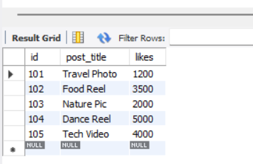

CREATE TABLE Users (
id INT PRIMARY KEY,
username VARCHAR(50),
followers INT
);

CREATE TABLE Posts (
id INT PRIMARY KEY,
post_title VARCHAR(100),
likes INT
);

INSERT INTO Users VALUES
(1,'Rahul',5000),
(2,'Priya',8000),
(3,'Amit',3000),
(4,'Neha',9000),
(5,'Riya',7000);

INSERT INTO Posts VALUES
(101,'Travel Photo',1200),
(102,'Food Reel',3500),
(103,'Nature Pic',2000),
(104,'Dance Reel',5000),
(105,'Tech Video',4000);

WITH TopUsers AS
(
SELECT username, followers
FROM Users
ORDER BY followers DESC
LIMIT 3
),
TopPosts AS
(
SELECT post_title, likes
FROM Posts
ORDER BY likes DESC
LIMIT 3
)

SELECT
'User' AS Type,
username AS Name,
followers AS Count
FROM TopUsers

UNION ALL

SELECT
'Post',
post_title,
likes
FROM TopPosts;

4.
Write a recursive CTE that generates a list of dates for the next 7 days starting from today, similar to how BookMyShow shows available dates for movie bookings.<br><br><em><strong>Hint:</strong> Use a base case for today and recursion to add one day at a time.</em>
Ans :
WITH RECURSIVE Next7Days AS
(
SELECT
CURDATE() AS booking_date,
1 AS day_no

UNION ALL

SELECT
DATE_ADD(booking_date, INTERVAL 1 DAY),
day_no + 1
FROM Next7Days
WHERE day_no < 7
)

SELECT booking_date
FROM Next7Days;
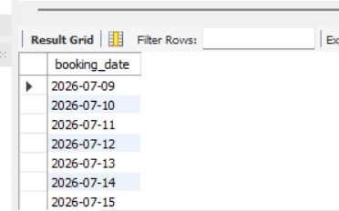

5.
Given a messy SQL query that finds all users with more than 1000 followers from a 'Users' table, refactor it to use a CTE for better clarity and maintainability.
Ans :
WITH PopularUsers AS
(
SELECT *
FROM Users
WHERE followers > 1000
)
SELECT *
FROM PopularUsers;

